Mathematics: Units 3A and 3B
Formula sheet

Number and algebra: Estimation and calculation

Index laws:
For 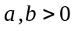and m ,n real,
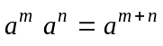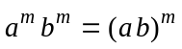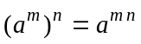

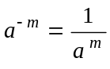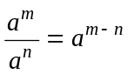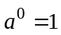
For m an integer and n a positive integer 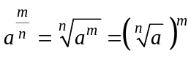

Number and algebra: Calculus

Differentiation
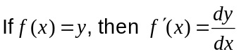

Product rule:
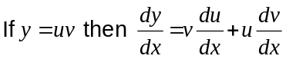

Integration

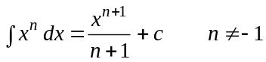

Space and measurement: Measurement

In any triangle ABC,
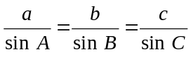

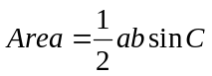

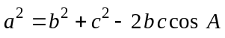

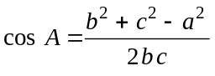

Space and measurement: Measurement
Trapezium: Area = 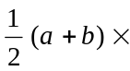height, where a and b are the lengths of the parallel sides

Prism: Volume = Area of base height

Cylinder: Total surface area = 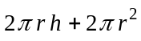
Volume = 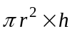

Pyramid: Volume = area of base height

Cone: Total surface area = 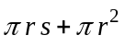, s is the slant height
Volume = 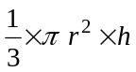

Sphere: Total surface area = 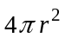
Volume = 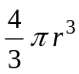

Chance and data: Quantify chance

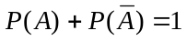

In a normal distribution approximately:
68% of values lie within one (1) standard deviation of the mean
95% of values lie within two (2) standard deviations of the mean
99.7% of values lie within three (3) standard deviations of the mean.

Note: Any additional formulas identified by the examination panel as necessary will be included in the body of the particular question.

